Telco Customer Churn Analysis

--All Customer Details
SELECT * FROM telco_customers;
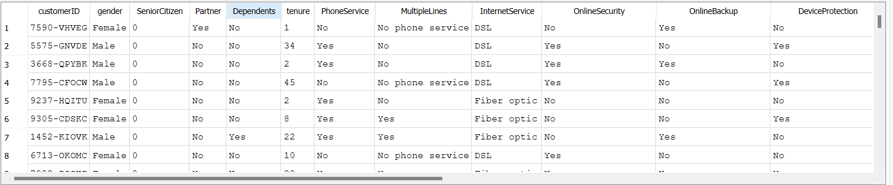

--Total Customers
SELECT COUNT(*) FROM telco_customers;
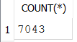

--Unique Customers & Churned Customers
SELECT
COUNT(DISTINCT customerID),
SUM(CASE WHEN Churn = 'Yes' THEN 1 ELSE 0 END) AS churned_customers
FROM telco_customers;
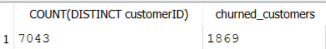

--Total Unique Customers
SELECT COUNT(DISTINCT customerID) FROM telco_customers;
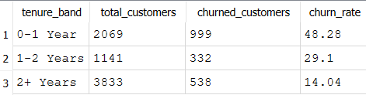

--Churned vs Non-Churned Customers
SELECT Churn, COUNT(*)
FROM telco_customers
GROUP BY Churn;
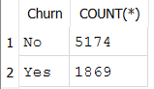

--Churned Customers
SELECT COUNT(*) AS churned_customers
FROM telco_customers
WHERE Churn = 'Yes';
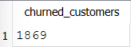

--Churn Rate %
SELECT
ROUND(
100.0*SUM(CASE WHEN Churn = 'Yes' THEN 1 ELSE 0 END) / COUNT(*),2 )AS churn_rate_percent
FROM telco_customers;
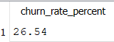
--Active Customers
SELECT COUNT(*) AS active_customers
FROM telco_customers
WHERE Churn = 'No';
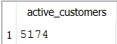

--Avg Monthly Charges
SELECT ROUND(AVG(MonthlyCharges),2) AS avg_monthly_charges
FROM telco_customers;
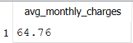

--Avg Tenure
SELECT ROUND(AVG(tenure), 1) AS avg_tenure_months
FROM telco_customers;
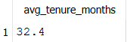

--Churn by Contract Type
SELECT * FROM churn_by_contract;
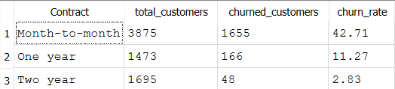
--Churn by Payment Method
SELECT
PaymentMethod,
COUNT(*) AS total_customers,
SUM(CASE WHEN Churn = 'Yes' THEN 1 ELSE 0 END) AS churned_customers,
ROUND(
100.0 * SUM(CASE WHEN Churn = 'Yes' THEN 1 ELSE 0 END) / COUNT(*),2)AS churn_rate
FROM telco_customers
GROUP BY PaymentMethod;

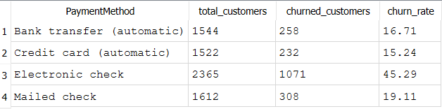

--Churn by Internet Service
SELECT
InternetService,
COUNT(*) AS total_customers,
SUM(CASE WHEN Churn = 'Yes' then 1 else 0 END) AS churned_customers,
ROUND(
100.0 * SUM(CASE WHEN Churn = 'Yes' THEN 1 ELSE 0 END) / COUNT(*),2
) AS churn_rate
FROM telco_customers
GROUP BY InternetService;

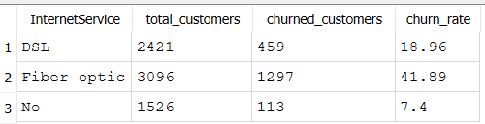

--Churn by Tenure Band
SELECT
CASE
WHEN tenure < 12 THEN '0-1 Year'
WHEN tenure <= 24 THEN '1-2 Years'
ELSE '2+ Years'
END AS tenure_band,
COUNT(*) AS total_customers,
SUM(CASE WHEN Churn = 'Yes' THEN 1 ELSE 0 END) AS churned_customers,
ROUND(
100.0 * SUM(CASE WHEN Churn = 'Yes' THEN 1 ELSE 0 END)/ COUNT(*),2) AS churn_rate
FROM telco_customers
GROUP BY tenure_band;

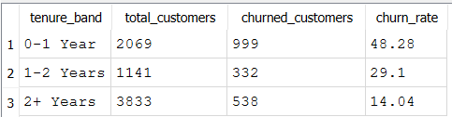

--Top 10 Risk Customers
SELECT
customerID,
tenure,
MonthlyCharges
FROM telco_customers
WHERE Churn='Yes'
ORDER BY MonthlyCharges DESC
LIMIT 10;
